


電影名稱:_____________________ 欣賞日期:___/___；___/___ 任課教師:____________老師
輔英科技大學 運動電影賞析心得報告

□二技□四技□五專 _________科系____年____班 學號:____________ 姓名:_____________
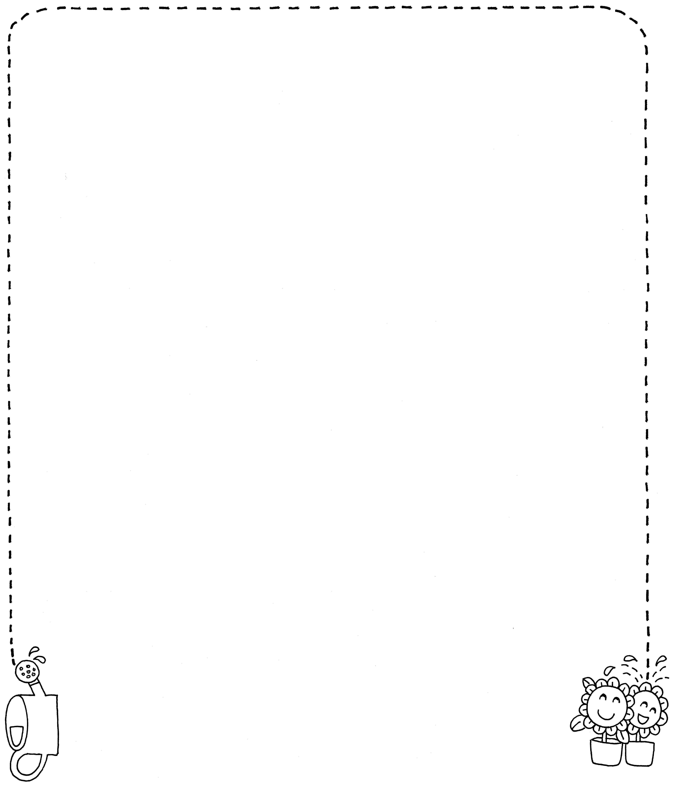
_
_____________________________________________________________________________________________________________________________________________________________________________________________________________________________________________________________________________________________________________________________________________________________________________________________________________________________________________________________________________________________________________________________________________________________________________________________________________________________________________________________________________________________________________________________________________________________________________________________________________________________________________________________________________________________________________________________________________________________________________________________________________________________________________________________________________________________________________________________________________________________
__________________________________________________________
不敷使用，請翻面續寫...

